**ISTEP REVIEW # 5 Name:______________________**

**Due Date: _____________**

1. The Chief sells ice cream cones for $ 3.50 and banana splits for $5. On a hot summer day, the shop sold 8 more ice cream cones than banana splits and made $240.50. How many ice cream cones and banana splits were sold?
2. Define the variables for the problem.
3. Write two equations.
4. Solve the equations. Solutions _______________________________________

2) Write the domain and range for the following functions.

A) D:

R:

B)

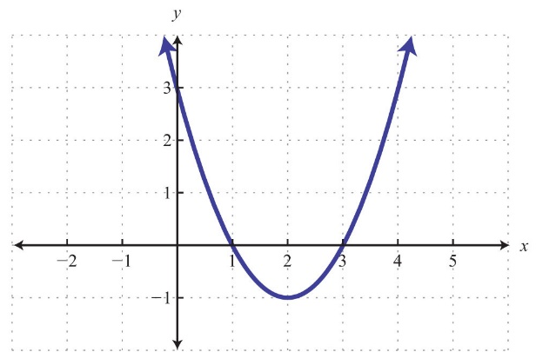 D:

R:

3) Which expression is equivalent to ?

1.  b)  c)  d) 

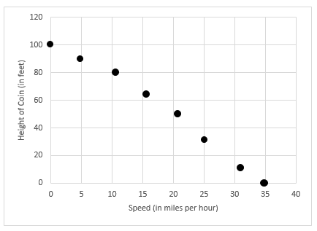4) A penny is dropped from a balcony and takes approximately 3.7 seconds to reach the ground. The graph below shows the speed of the penny throughout its fall.

1. What is the y-intercept? ____________
2. What does the y-intercept represent? ___________________________________

___________________________________

1. How fast is the coin moving when it hits the ground?

____________________________________

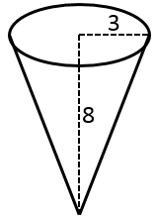5) Jimmy bought an ice-cream cone from The Chief. It was a waffle cone so it was in the shape of a right circular cone. The cone is 8 inches tall and the radius of the top is 3 inches. Find the volume of the cone to the nearest cubic inch. Volume for right circular cone: 

6) Circle all the graphs that represent a function.

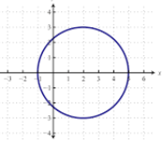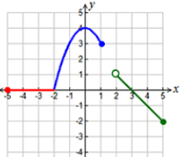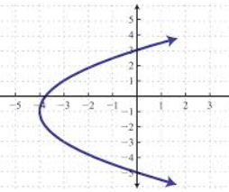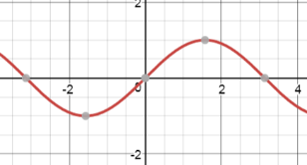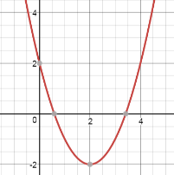

1. B) C) D) E)