ISTEP REVIEW #4 Name:_______________________

Due Date:___________________

1. In a certain type of lily plant is growing in a pond in such a way that the number of plants is growing exponentially. The number of plants, N, in the pond at time t is modeled by the function , where a and b are constants and t is measured in months. The table shows two values of the function.

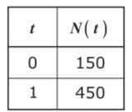Which equation can be used to find the number of plants in the pond at the time t?

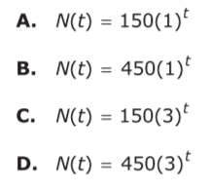

1. Jerome is constructing a table of values that satisfies the definition of a function.

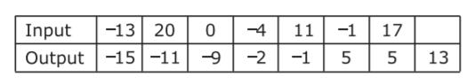

Which number(s) can be placed in the empty cell so that the table of values satisfies the definition of a function?

Select ***all*** that apply.

1. -5 b) -1 c) 0 d) 2 e) 11 f) 17
2. Naomi left her apartment and went for a bicycle ride, returning to her apartment after 2 hours. The graph shows how her distance from home varied during that time.

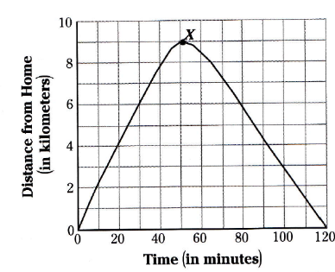Which of the following best describes the meaning of the point marked X on the graph?

* 1. The greatest distance from home that Naomi reached.
  2. The moment when Naomi returned home.
  3. The fastest speed that Naomi reached.
  4. The time Naomi stopped for a rest.

1. Which series of transformations can be used on the parallelogram in the coordinate grid so that each of its 4 vertices will have a pair of negative coordinates?
   1. 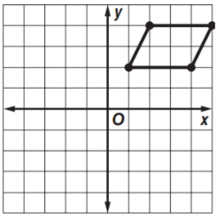Translate 6 units down, and then reflect over the x-axis.
   2. Rotate 90 degrees counterclockwise and then reflect over the y-axis.
   3. Translate 6 units to the left, and then 3 units down.
   4. Translate 6 units to the left, and then reflect over the x-axis.
2. Look at the function: .
3. Use factoring to find the zeros of . Show your work:
4. What are the x-intercept(s) of the graph of ?
5. Explain how you found your answer:
6. Luke was asked to demonstrate how to solve the equation . Determine if each of Luke’s steps is correct or incorrect, **based on the preceding step.** If a step is incorrect, describe the error and explain what Luke should have done instead. (There are multiple mistakes)

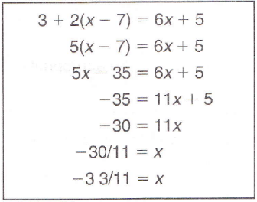

Step 1

Step 2

Step 3

Step 4

Step 5

Step 6

Step 7