ISTEP REVIEW #1 Name:___________________
Due Date:___________________
- You can choose between two tennis courts at two university campuses to learn how to play tennis. Campus A charges $25 per hour. Campus B charges $20 per hour plus a one-time registration fee of $10.

  - Write a system of equations to represent the cost c for h hours of court use at each campus

  - Find the number of hours in which the costs are the same.

  - On Saturday, Sierra decides she will practice tennis for 3 consecutive hours. Which campus should she go to and why?

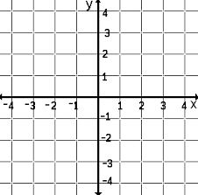
- Graph the following system of inequalities: $\left\{\begin{aligned}y<x-1 \\ y≥-2x+1\end{aligned}\right.$

- Completely factor the following expressions:
  - $2x^{2}+11x+5$ b) 4x² – 49

- What is the value of the expression for the given values of each variable?
  - $7\left(a+4\right)+3b-8$ for $a=-4$ and $b=5$

  - $\frac{1}{2}a-5b+12$ for $a=10$ and $b=2$

- A rectangle with an area of 165cm² has a width that is 4 centimeters less than its length.

a. Write an equation representing the area of the rectangle. Use x to represent the length of the rectangle.

b. Solve your equation for all values of x.

c. Use your solution to the equation to identify the length and width of the rectangle. Explain how you determined which value(s) of x to use.

